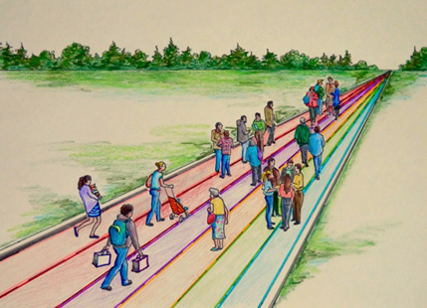

THINKING OTHERWISE:
A CONVERSATION ABOUT EDUCATION
WITH DON GLENDENNING

Inspire Centre
WWW Street, Smmerside
12:00-1:00 pm
March 1, 2018

NEED A SPEAKER

FOR YOUR NEXT MEETING?

Don Glendenning grew up on the banks of the Miramichi in New Brunswick. He began teaching at age 17 and ended up as the Founding President of Holland College in Prince Edward Island. Along the way he was a principal, a Teacher Trainer, and Training Consultant with Department of Labour in Ottawa. He also studied at Bradley University, University of London (Eng.) and Indiana University.

After retirement he formed his own consulting firm and worked both in Canada and overseas.

His passion is education, which he views as the act helping people learn new attitudes, skills and knowledge in order to thrive on the road of life. He’d like to see our education sstem become more focused on learners and their needs, more flexible and more transparent.

So, if you want a speaker, are interested in education and other approaches, see below:
Education 20/20 Inc.
WWW,educaation2020.ca
Tel: 902-892-2060
pei@ducation2020.ca
Pres-1

